**“ONLINE GROCERY STORE USING PHP”**

# A project report submitted in the partial fulfillment of the requirements for

the award of the degree of

**BACHELOR OF TECHNOLOGY**

In

**COMPUTER SCIENCE AND ENGINEERING**

# By

**K ANU PRIYA**

**(211801380003)**

*Under the esteemed Guidance of*

**M. Aswini Kumar,**

**Asst. Professor**

Department of Computer Science and Engineering

Centurion University Technology and Management



# CENTURION UNIVERSITY OF TECHNOLOGY

# & MANAGEMENT

Vizianagaram, Andhra Pradesh

(2022-2023)

# CENTURION UNIVERSITY OF TECHNOLOGY

&MANAGEMENT

# VIZIANAGARAM-535003

ANDHRA PRADESH, INDIA



# 

# CERTIFICATE

This is to certify that the Thesis/Dissertation work entitled “ONLINE GROCERY STORE USING PHP ” is a bonafide record prepared by K. ANU PRIYA bearing roll no:211801380003 during 2022-2023 in the partial fulfillment of the requirements for the award of the degree Bachelor Of Technology In Computer Science And Engineering in the department of computer science and engineering, Centurion University of Technology & Management Vizianagaram, The results embodied in this project have not been submitted to any other University or Institute for the award of any degree or diploma.

|  |  |
| --- | --- |
| **INTERNAL GUIDE**          **ASWINI KUMAR** M. Tech.,  Asst. Professor  Dept. Of CSE | **HEAD OF THE DEPARTMENT**  **R. LAKSHMANA RAO** M. Tech-, (Ph.D.)  Asst. Professor &  Head of the Department  Dept. Of CSE |

**EXTERNAL EXAMINER**

# DECLARATION

I hereby solemnly declare that the work done on the project entitled “ONLINE GROCERY STORE USING PHP” submitted to the department of computer science and engineering, Centurion University of Technology & Management Vizianagaram, is prepared by me and was not submitted to any other institution for the award of any other degree.

K Anu Priya (211801380003)

## ACKNOWLEDGEMENT

It is with at most pleasure and excitement we submit our project partial fulfillment of the requirement for the award of Bachelor of Technology.

The project is a result to the cumulate efforts, support, guidance, encouragement and inspiration from many of those for whom we have to give our truthful honor and express gratitude through bringing out this project at the outset as per our knowledge.

I convey my special thanks to our project **Guide Mr. M. ASWINI KUMAR, (Asst. Prof.)** who has guided, encouraged and tremendously supported me to enhance my knowledge with present working of this project to bring out enriching the quality of project.

I express my appreciativeness to **Mr. R. LAKSHMANA RAO (Asst. Prof.) and Head of the Department,** who facilitated us to providing the friendly environment which helped to enhance my skills in present project.

I would also like to extend my gratitude to **Dr. K. V. G. KRISHNA MURTHY, DeanSchool of Engineering and Technology, Centurion University of Technology and Management** who has helped us to attain all the requirements of the project.

I convey my sincere thanks to **Dr. RAMANA RAO, Ph. D Registrar of Centurion University of Technology and Management** who provided us with an opportunity to take on project work in well-equipped laboratories of Computer Science Department in our college.

At the outset, we thank to **Sri. G.S.N. RAJU**, beloved **Vice Chancellor of Centurion University of Technology and Management** who is the back bone by providing for completion of this project, Thank you sir.

## ABSTRACT

The Online Grocery Store using PHP is a web-based application that allows users to conveniently purchase groceries online. The project aims to provide a seamless shopping experience to customers, allowing them to browse through a wide range of grocery products, add items to their shopping cart, and proceed to checkout for order placement and payment. The application is developed using PHP, a popular scripting language for web development, along with HTML, CSS, and JavaScript to create an interactive and user-friendly interface.

**Key Words**: Online payment, Delivery address, Product management, Payment options, Admin dashboards, Order fulfilment.

## LIST OF FIGURES

|  |  |  |
| --- | --- | --- |
| **S.NO** | **NAME** | **Pg. No** |
| 8.1 | Home Page | 18 |
| 8.2 | About Page | 18 |
| 8.3 | Login Page | 19 |
| 8.4 | Admin Dashboard | 19 |

## CONTENTS

|  |  |  |
| --- | --- | --- |
| S.NO | TOPIC NAME | Page. No |
|  | ACKNOWLEDGEMENT  DECLARATION  CONTENTS  ABSTRACT |  |
| 1 | INTRODUCTION | 1-3 |
| 2 | SYSTEM ANALYSIS |  |
| 3 | ABOUT THE PROJECT | 6 |
| 4 | SYSTEM REQUIREMENTS | 7-8 |
| 5 | IMPLEMENTATIONS | 9 |
| 6 | OUTPUT SCREENS | 10-17 |
| 7 | SYSTEM TESTING | 18-19 |
| 8 | CONCLUSION | 20-22 |
| 9 | FUTURE WORK | 23 |
| 10 | BIBILOGRAPHY | 24 |

## 1. INTRODUCTION

The main goal for developing this project where customer can purchase an order on groceries. The structure is very convenient for customer. They can easily buy the grocery products from home through internet. The system decrease a much of work load for customer. The product is directly delivered customer address by system online grocery shopping. The system functionality of products an order is stored on the admin side in web service. This project provides a lot of features to manage the product in well manner. This project contains details advance module that can make the backend system very powerful.

E-Commerce that allows customer to buy a product form a seller over internet. There had been an increasing demand for e commerce sites, in the past decades. Online grocers, especially have growing in popularity. Each of these sites are using recommendation system and algorithms. Internet of Everything or Network of Everything is additionally known as Internet of Things (IoT).

When physical articles or things are embedded with physics, sensors and software then the network called IOT is formed. This network has property to change objects to exchange knowledge with the assembly, operator and/or different connected devices supported the infrastructure of International Telecommunication Union's international Standards Initiative.

IOT allows the discernment of objects and controlling them remotely across existing network infrastructure. Thus, a network makes an extent for a lot of direct integration between the physical world and computer based systems. This brings to betterment in accuracy, potency and economic profit. Every factor is clearly acknowledgeable through its embedded system however is in a position to interoperate among the present internet infrastructure. The intention of here tabloid is to create an online grocery management system. This system can come with suitable recommendation for the user and display interesting patterns for companies which can be also market research.

* 1. **PURPOSE OF THE PROJECT**

Online grocery shopping attempts to enhance admittance to care and improve the continuousness and good organization of services. Depends on the particular setting and local case executives are responsible for a diversity of tasks, position from linking clients to the services to really providing intensive shop and delivery facilities themselves.

* 1. **EXISTING SYSTEM & DISADVANTAGES**

The current system for shopping is to visit the shop manually and from the available grocery item choose the item user want and buying the item by payment of the price of the item. Grocery stores also offer non-perishable foods that are packaged in bottles, boxes, and cans; some also have bakeries, butchers, delis, and fresh produce. Large grocery stores that stock significant amounts of non-food grocery items, such as clothing and household items are called supermarkets. Some large supermarkets also include a pharmacy, and user service, redemption, and electronics sections. Some grocery stores (especially large ones) form the center piece of a larger complex that includes other facilities, such as gas stations, which will often operate under the store's name. Some groceries specialize in the foods of a certain nationality or culture. These stores are known as ethnic markets and may also serve as gathering places for immigrants. In many cases, the wide range of grocery items carried by larger supermarkets has reduced the need for such specialty stores the variety and availability of food is no longer restricted by the diversity of locally grown food or the limitations of the local growing season.

**DISADVANTAGES OF EXISTING SYSTEM:**

* User must go to shop and select grocery items.
* It is difficult to identify the required grocery item.
* Description of the grocery item limited.
* It is a time consuming process
* Not in reach of distant users.
* It is less user-friendly.

**1.3. PROPOSED SYSTEM & IT’S ADVANTAGES:**

**PROPOSED SYSTEM**

To overawed all these problems that is mentioned in existing system, we are evolving a solution that is, as an alternative to go in shopping mall and store, we can chase for the good using our mobile, through internet make shopping easy. Delivery options are added in system that’s help for customer. We can added products also delete in cart. The best service give to customer and money on distribution accessible that’s makes a helpful system to customer. The duration of time taken by ultrasonic pulses to extend to the surface of the medium and back is used to control continuous level measurement. The improve angle during filling and emptying granulated solids and also the rough liquid surfaces effect the reflection of the ultrasonic pulse. This will also affect the measurement of Chemical and physical properties of the medium don't affect the measurement result. Hence the abrasive and aggressive, viscous and adhesive media will be simply measured.

**ADVANTAGES OF PROPOSED SYSTEM:**

* Save on transportation costs. Back when I was working away from home, I simply scheduled my time to swing by the grocery store on the way home from work
* Save time. A 28-mile round trip, plus whatever time it takes to shop can easily burn up an hour or more of my day.
* Stay organized.

## 2.SYSTEM ANALYSIS

### 2.1. STUDY OF THE SYSTEM

To provide flexibility to the users, the interfaces have been developed that are accessible through a browser. The GUI’S at the top level have been categorized as

1. Administrative user interface
2. The operational or generic user interface

The ‘administrative user interface’ concentrates on the consistent information that is practically, part of the organizational activities and which needs proper authentication for the data collection. These interfaces help the administrators with all the transactional states like Data insertion, Data deletion and Date updation along with the extensive data search capabilities.

The ‘operational or generic user interface’ helps the end users of the system in transactions through the existing data and required services. The operational user interface also helps the ordinary users in managing their own information in a customized manner as per the included

flexibilities

**2.2. INPUT & OUTPUT REPRESENTATION**

Input design is a part of overall system design. The main objective during the input design is as given below: • To produce a cost-effective method of input. • To achieve the highest possible level of accuracy. • To ensure that the input is acceptable and understood by the user.

**INPUT STAGES:**

The main input stages can be listed as below:

* Data recording
* Data transcription
* Data conversion

## 3. ABOUT THE PROJECT

The Online Grocery Store PHP project is a web-based application that aims to provide users with a convenient and seamless platform to purchase groceries online. The project leverages PHP, along with other web technologies like HTML, CSS, and JavaScript, to create an interactive and user-friendly online store.

Key Features of the Online Grocery Store PHP Project:

**User Registration and Login:** The project includes a user registration system where new customers can create accounts by providing their details. Registered users can then log in using their credentials to access the shopping features and personalized functionalities.

**Product Catalog:** The project offers a comprehensive catalog of grocery products, organized into different categories for easy navigation. Users can browse through the catalog, view product details, and add items to their shopping cart.

**Shopping Cart:** The project incorporates a shopping cart functionality that allows users to add multiple products to their cart while browsing the catalog. Users can modify quantities, remove items, and view the total cost of their selected items.

**Checkout Process:** Once users have finished adding products to their cart, they can proceed to the checkout process. Here, users can review their order, select a preferred delivery address, and choose a payment method.

**Payment Gateway Integration:** The project integrates a secure payment gateway to facilitate online transactions. Users can make payments using credit/debit cards, net banking, or other available payment options. The integration ensures that transactions are secure and user payment information is protected.

**Order Tracking:** After successful order placement and payment, users can track the status of their orders. The project provides updates on order processing, packaging, and delivery, allowing users to stay informed about their purchases.

**Admin Dashboard:** The project includes an admin dashboard that enables the system administrator to manage various aspects of the online grocery store. The dashboard provides functionalities for managing products, inventory, user accounts, order details, and generating reports.

**User Reviews and Ratings:** Users can provide feedback on purchased products by rating and reviewing them. This feature allows other users to make informed decisions while shopping and helps maintain product quality and customer satisfaction.

**Search Functionality:** The project incorporates a search feature that allows users to search for specific products or browse products within specific categories. This enhances the user experience and makes it easier to find desired items.

**Responsive Design:** The project focuses on creating a responsive design that adapts to different screen sizes and devices. This ensures that users can access the online grocery store seamlessly from desktops, laptops, tablets, and mobile devices.

The Online Grocery Store PHP project aims to provide a user-friendly and efficient platform for customers to shop for groceries online. By leveraging PHP and related technologies, the project offers essential features such as user registration, product catalog, shopping cart, secure payment integration, order tracking, and an admin dashboard for effective management.

## 4. SYSTEM REQUIREMENTS AND SPECIFICATIONS

### 4.1. Hardware Requirements

* Processor : Pentium-III (or) Higher
* RAM : 64MB (or) Higher
* Cache : 512MB
* Hard disk : 10GBSOFTWARE COMPONENTS

### 4.2. Software Requirements

* Operating System : Windows Family or higher version
* Techniques : JDK 1.7
* Data Bases : MySQL
* Server :Apache Tomcat

## 5. IMPLEMENTATION

### 5.1 SOURCE CODE

<?php

$con=mysqli_connect("localhost","root","","grocerydb"); **if**(!$con) {

**die**("cannot connect to server");

}

?>

<html>

<head>

<meta http-equiv="Content-Type" content="text/html; charset=UTF-8">

<title>Add List</title>

<link rel="stylesheet" href=

["https://maxcdn.bootstrapcdn.com/bootstrap/4.4.1/css/bootstrap.min. css"](https://maxcdn.bootstrapcdn.com/bootstrap/4.4.1/css/bootstrap.min.css)>

<link rel="stylesheet" href="css/style.css">

</head>

<body>

<div **class**="container mt-5">

<h1>Add Grocery List</h1>

<form action="add.php" method="POST">

<div **class**="form-group">

<label>Item name</label> <input type="text" **class**="form-control" placeholder="Item name" name="iname" />

</div>

<div **class**="form-group">

<label>Item quantity</label> <input type="text" **class**="form-control" placeholder="Item quantity" name="iqty" />

</div>

<div **class**="form-group">

<label>Item status</label> <select **class**="form-control" name="istatus"> <option value="0"> PENDING

</option>

<option value="1">

BOUGHT

</option>

<option value="2">

NOT AVAILABLE

</option>

</select>

</div>

<div **class**="form-group">

<label>Date</label> <input type="date" **class**="form-control" placeholder="Date" name="idate">

</div>

<div **class**="form-group"> <input type="submit" value="Add" **class**="btn btn-danger" name="btn">

</div>

</form>

</div>

<?php **if**(isset($_POST["btn"])) { **include**("connect.php"); $item_name=$_POST['iname'];

$item_qty=$_POST['iqty'];

$item_status=$_POST['istatus'];

$date=$_POST['idate'];

$q="insert into grocerytb(Item_name, Item_Quantity,Item_status,Date) values('$item_name',$item_qty,

'$item_status','$date')";

mysqli_query($con,$q);

header("location:index.php");

}

// if(!mysqli_query($con,$q))

// {

// echo "Value Not Inserted";

// }

// else

// {

// echo "Value Inserted";

// }

?>

</body> </html>

@import url(

['https://fonts.googleapis.com/css2?family=Poppins:wght@300;400;700& display=swap'](https://fonts.googleapis.com/css2?family=Poppins:wght@300;400;700&display=swap));

body {

**font-family**: 'Poppins', sans-serif;

**font-weight**: 300; **background-color**: beige;

}

h1, h2, h3, h4, h5 {

**font-family**: 'Poppins', sans-serif; **font-weight**: 700;

}

<?php

**include**("connect.php");

**if** (isset($_POST['btn'])) {

$date=$_POST['idate'];

$q="select * from grocerytb where Date='$date'";

$query=mysqli_query($con,$q);

} **else** {

$q= "select * from grocerytb";

$query=mysqli_query($con,$q);

}

?>

<html>

<head>

<meta http-equiv="Content-Type"

content="text/html; charset=UTF-8">

<title>View List</title>

<link rel="stylesheet" href=

["https://maxcdn.bootstrapcdn.com/bootstrap/4.4.1/css/bootstrap.min. css"](https://maxcdn.bootstrapcdn.com/bootstrap/4.4.1/css/bootstrap.min.css)>

<link rel="stylesheet" href="css/style.css">

</head>

<body>

<div **class**="container mt-5">

<!-- top -->

<div **class**="row">

<div **class**="col-lg-8">

<h1>View Grocery List</h1>

<a href="add.php">Add Item</a>

</div>

<div **class**="col-lg-4">

<div **class**="row">

<div **class**="col-lg-8">

<!-- Date Filtering-->

<form method="post" action=""> <input type="date" **class**="form-control" name="idate">

<div **class**="col-lg-4" method="post"> <input type="submit"

**class**="btn btn-danger float-right" name="btn" value="filter">

</div>

</form>

</div>

</div>

</div>

</div>

<!-- Grocery Cards -->

<div **class**="row mt-4">

<?php

**while** ($qq=mysqli_fetch_array($query)) {

?>

<div **class**="col-lg-4">

<div **class**="card">

<div **class**="card-body">

<h5 **class**="card-title">

<?php echo $qq['Item_name']; ?>

</h5>

<h6 **class**="card-subtitle mb-2 text-muted">

<?php echo

$qq['Item_Quantity']; ?>

</h6> <?php

**if**($qq['Item_status'] == 0) {

?>

<p **class**="text-info">PENDING</p>

<?php

} **else** **if**($qq['Item_status'] == 1) {

?>

<p **class**="text-success">BOUGHT</p>

<?php } **else** { ?>

<p **class**="text-danger">NOT AVAILABLE</p>

<?php } ?>

<a href=

"delete.php?id=<?php echo $qq['Id']; ?>"

**class**="card-link">

Delete

</a>

<a href=

"update.php?id=<?php echo $qq['Id']; ?>"

**class**="card-link">

Update

</a>

</div>

</div><br>

</div>

<?php

}

?>

</div>

</div>

</body>

</html>

<?php

**include**("connect.php");

**if**(isset($_POST['btn']))

{

$item_name=$_POST['iname']; $item_qty=$_POST['iqty'];

$istatus=$_POST['istatus'];

$date=$_POST['idate'];

$id = $_GET['id'];

$q= "update grocerytb set Item_name='$item_name',

Item_Quantity='$item_qty',

Item_status='$istatus', Date='$date' where Id=$id";

$query=mysqli_query($con,$q); header('location:index.php');

}

**else** **if**(isset($_GET['id']))

{

$q = "SELECT * FROM grocerytb WHERE Id='".$_GET['id']."'";

$query=mysqli_query($con,$q);

$res= mysqli_fetch_array($query);

}

?>

<html>

<head>

<meta http-equiv="Content-Type" content="text/html; charset=UTF-8">

<title>Update List</title>

<link rel="stylesheet" href=

["https://maxcdn.bootstrapcdn.com/bootstrap/4.4.1/css/bootstrap.min. css"](https://maxcdn.bootstrapcdn.com/bootstrap/4.4.1/css/bootstrap.min.css)>

<link rel="stylesheet" href="css/style.css">

</head>

<body>

<div **class**="container mt-5">

<h1>Update Grocery List</h1> <form method="post">

<div **class**="form-group">

<label>Item name</label> <input type="text" **class**="form-control" name="iname" placeholder="Item name" value=

"<?php echo $res['Item_name'];?>" />

</div>

<div **class**="form-group">

<label>Item quantity</label> <input type="text" **class**="form-control" name="iqty"

placeholder="Item quantity"

value="<?php echo $res['Item_Quantity'];?>" />

</div>

<div **class**="form-group">

<label>Item status</label> <select **class**="form-control" name="istatus">

<?php

**if**($res['Item_status'] == 0) {

?>

<option value="0" selected>PENDING</option>

<option value="1">BOUGHT</option>

<option value="2">NOT AVAILABLE</option>

<?php } **else** **if**($res['Item_status'] == 1) { ?>

<option value="0">PENDING</option>

<option value="1" selected>BOUGHT</option>

<option value="2">NOT AVAILABLE</option>

<?php } **else** **if**($res['Item_status'] == 2) { ?>

<option value="0">PENDING</option>

<option value="1">BOUGHT</option>

<option value="2" selected>NOT

AVAILABLE</option>

<?php

} ?>

</select>

</div>

<div **class**="form-group">

<label>Date</label>

<input type="date" **class**="form-control" name="idate" placeholder="Date" value="<?php echo $res['Date']?>">

</div>

<div **class**="form-group">

<input type="submit" value="Update" name="btn" **class**="btn btn-danger">

</div>

</form>

</div>

</body> </html>

<?php **include**("connect.php");

$id = $_GET['id'];

$q = "delete from grocerytb where Id = $id "; mysqli_query($con,$q);

?>

## 6. OUTPUT SCREENS

### 6.1. Home page

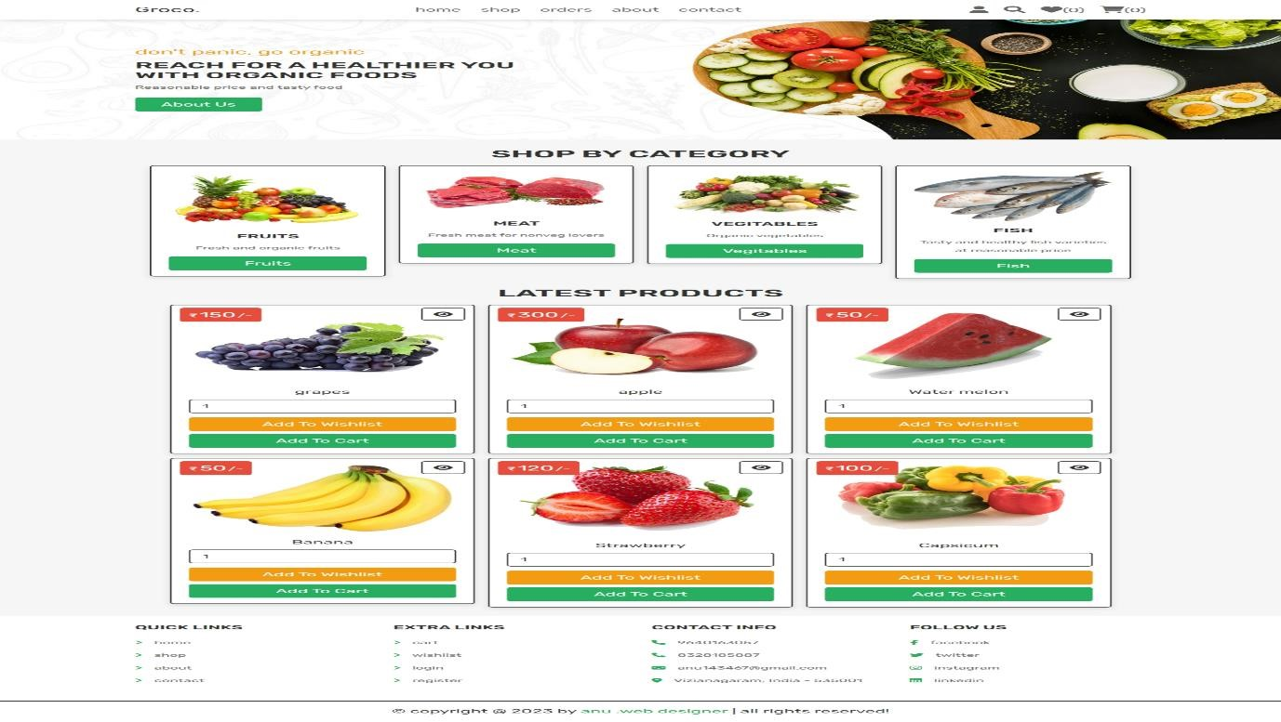

### 6.2. About page

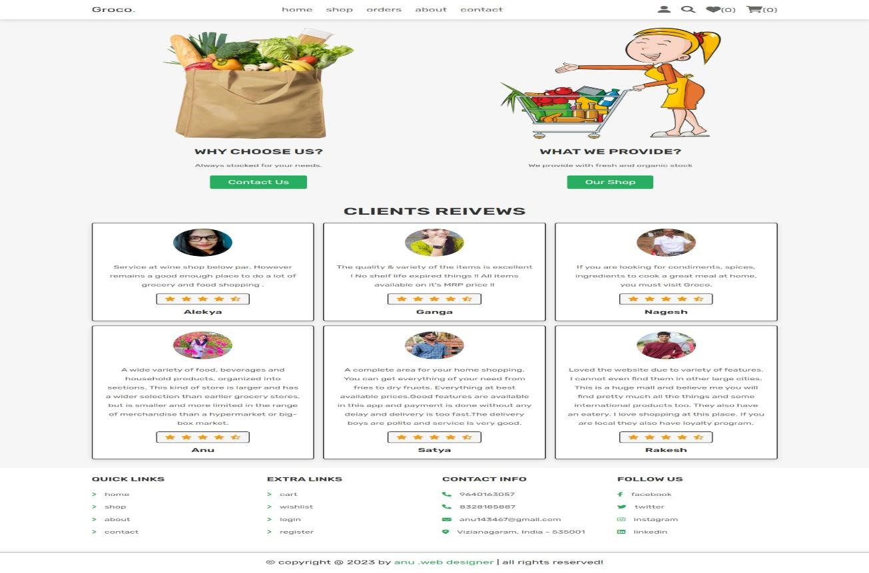

### 6.3. Login page

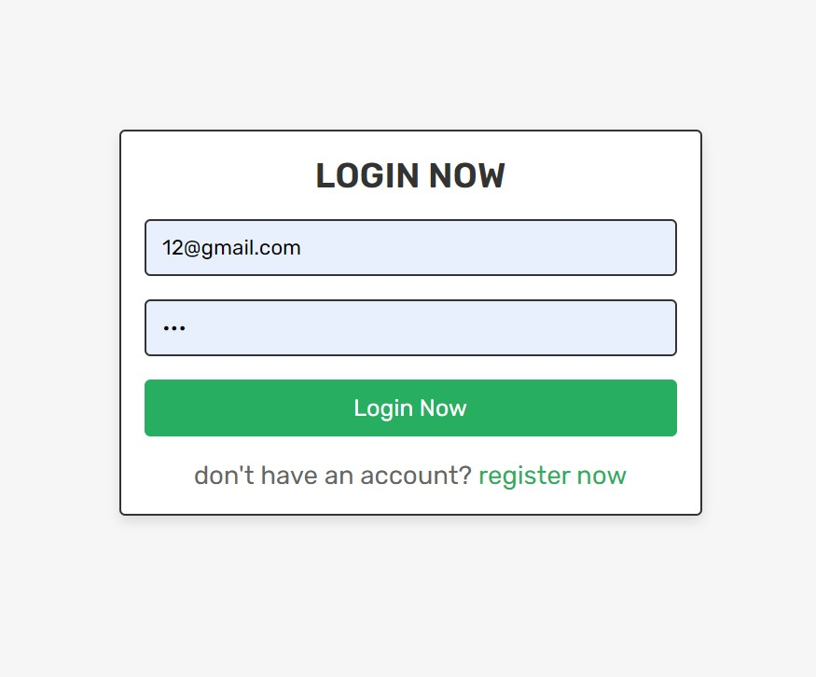

### 6.4. Admin dashboard

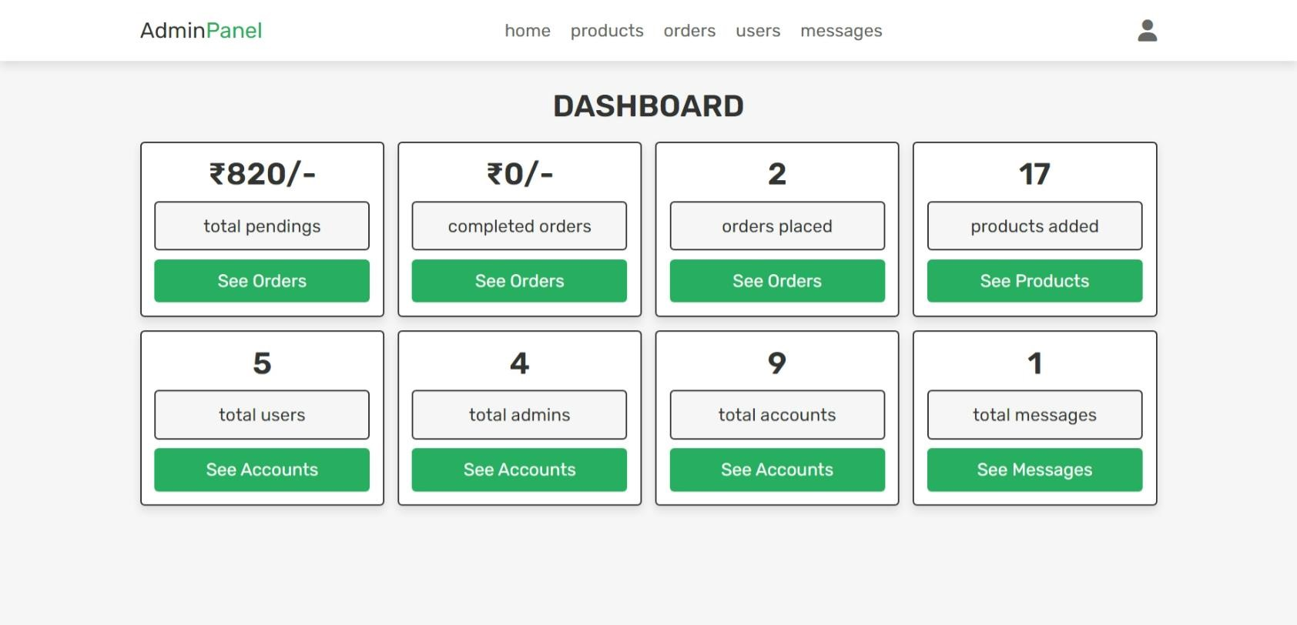

## 

## 7.SYSTEM TESTING

### 7.1. Software Testing

Testing is a process, which reveals errors in the program. It is the major quality measure employed during software development. During software development. During testing, the program is executed with a set of test cases and the output of the program for the test cases is evaluated to determine if the program is performing as it is expected to perform.

#### 7.2 Testing Methodologies

In order to make sure that the system does not have errors, the different levels of testing strategies that are applied at differing phases of software development are:

**Unit Testing:**

Unit Testing is done on individual modules as they are completed and become executable. It is confined only to the designer's requirements. Each module can be tested using the following two Strategies:

**Black Box Testing:**

In this strategy some test cases are generated as input conditions that fully execute all functional requirements for the program. This testing has been uses to find errors in the following categories:

* Incorrect or missing functions
* Interface errors
* Errors in data structure or external database access
* Performance errors
* Initialization and termination errors.
* In this testing only the output is checked for correctness.

**White Box testing :**

In this the test cases are generated on the logic of each module by drawing flow graphs of that module and logical decisions are tested on all the cases. It has been uses to generate the test cases in the following cases:

* Guarantee that all independent parts have been executed.
* Execute all logical decisions on their true and false Sides.
* Execute all loops at their boundaries and within their operational bounds
* Execute internal data structures to ensure their validity.

**Integrating Testing:**

Integration testing ensures that software and subsystems work together a whole. It tests the interface of all the modules to make sure that the modules behave properly when integrated together.

**System Testing:**

Involves in-house testing of the entire system before delivery to the user. Its aim is to

satisfy the user the system meets all requirements of the client's specifications. Acceptance Testing : It is a pre-delivery testing in which entire system is tested at client's site on real world data to find errors.

#### 7.3. Test cases

**• Testing can be done in two ways**:

Bottom up approach

Top down approach Bottom up Approach:

**Bottom-up Approach:**

Testing can be performed starting from smallest and lowest level modules and proceeding one at a time. For each module in bottom up testing a short program executes the module and provides the needed data so that the module is asked to perform the way it will when embedded within the larger system. When bottom level modules are tested attention turns to those on the next level that use the lower level ones they are tested individually and then linked with the previously examined lower level modules.

**Top-down approach:**

This type of testing starts from upper level modules. Since the detailed activities usually performed in the lower level routines are not provided stubs are written. A stub is a module shell called by upper level module and that when reached properly will return a message to the calling module indicating that proper interaction occurred. No attempt is made to verify the correctness of the lower level module. Validation: The system has been tested and implemented successfully and thus ensured that all the requirements as listed in the software requirements specification are completely fulfilled. In case of erroneous input corresponding error messages are displayed.

## 8. CONCLUSION

The project entitled ' Online Grocery Management System ' is very convenient for the Computer Companies. This system is very convenient for customer or users to buy online computer products. It can be observed that the information can be obtained easily and accurately. The online grocery shopping Software is made more user friendly to the users, so that anyone can run the software. Then this software provide permission to enter to the system via the login password credentials to the user who use this system. This project manages all the details about Computer Products.

## 10.FUTURE SCOPE

In Future users can buy there identical products using mobile phones. This organization is very beneficial for both users and companies. This product has great future scope. Online grocery project established using web based technology and for Windows too future versions of environments. This project also delivers security by using a security credentials like user id as well as password, so that any illegal users cannot practice your account. The only Lawful person that will consume proper admittance authority can use the online grocery shopping software.

## 11. BIBLIOGRAPHY

**BOOKS REFERED:**

* Active Server Pages for Dummies. IDG Books worldwide, 2001
* Scott Stabbert, Authentication and security for Internet developers • C#.NET Illuminated, Art Gittleman California State University, Long Beach
* C# Professional Projects, Nithin Pandey, Geetanjali Arora.
* Microsoft Visual C#. NET, Mickey Williams.

**ONLINE HELP:**

* Howard, Michael. “Microsoft Internet Information Server Security” available at
* www.csharpcorner.com
* www.microsoft.com/sql
* www.databasejournal.com/features/mssql
* [www.microsoft.com/vcshar](http://www.microsoft.com/vcshar)